**Service Descriptions:**

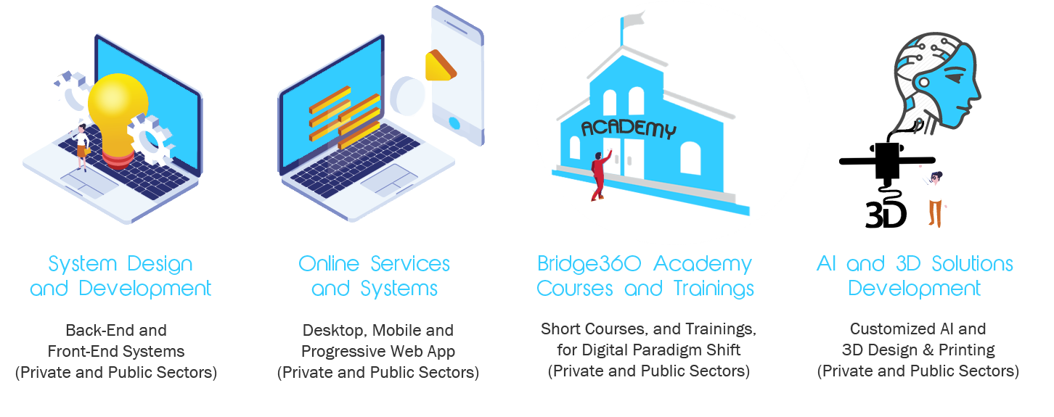

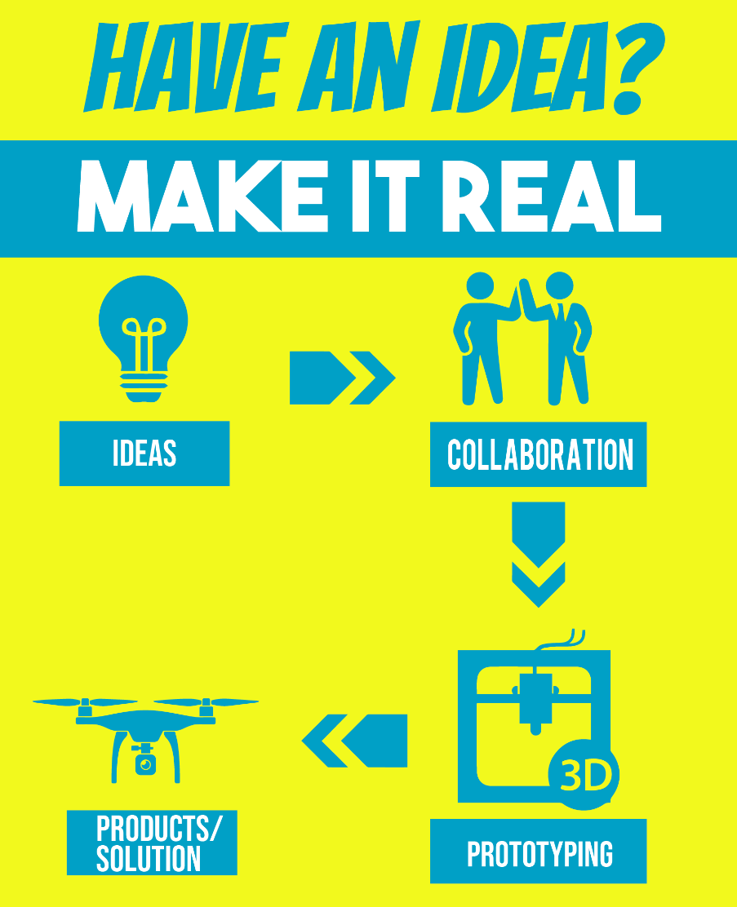

**System Design and Development:**

Bridge360 developers can plan, design, build, test, and deliver information systems that are customized to the clients’ needs.

**Online Services and Systems:**

Websites, web application, and mobile application development can be done affordably with the highest quality, especially for non-government organizations (NGOs), startups, and SMEs.

**Bridge360 Academy Courses and Trainings:**

Bridge360 core team could give lectures to students, professionals and businesses to help them understand the basics of Artificial Intelligence, 3D Design, and Solutions development and aid them in the Digital Transformation.

SHORT COURSES Available:

1. Requisites to Understanding AI Culture
   1. Redefining the Concept of Mind
   2. Redefining the Concept of Space
   3. Redefining the Concept of Life
   4. Redefining the Concepts of Knowledge and Civilization
2. Bite-sized Python
3. Bringing data to life: A Data Visualization Workshop
4. Learning Machine Learning using Python
5. Diving Deep into Deep Learning with Python
6. Basics of 3D Designing
7. Systems Thinking
8. Design Thinking

**AI and 3D Solutions Development:**

Our team developed an AI that could colorize black and white-colored images. It started as a low-resolution colorizer. Now, it can colorize higher resolution images within seconds. We could also develop other AI based on your needs. Contact us for more details.

